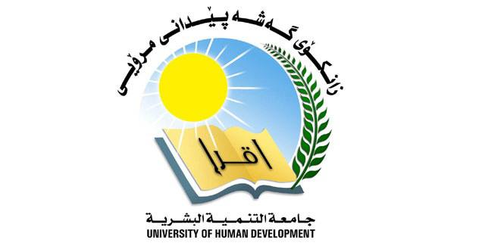

**University of Human Development**

**College of Science and Technology**

**Department of Information Technology**

**elon musk**

**Members:**

**['Diary Tariq Ibrahem']**

**Abstract**

Elon Musk is an entrepreneur and innovator best known for founding the aerospace company SpaceX, co-founding the electric car company Tesla Motors, and launching the revolutionary Hyperloop transportation system. He is also the CEO of Neuralink, a company developing advanced brain-computer interfaces. Musk has made a name for himself by pushing the boundaries of technology and business, and has become one of the world’s most successful and respected entrepreneurs.  
  
Musk is an advocate for renewable energy, and has invested heavily in solar power, electric cars, and battery technology. He has also been an outspoken advocate for the development of artificial intelligence, and has proposed a number of ambitious projects to make the world a better place. Musk has been described as a “visionary” and a “genius”, and his work has been praised by many of the world’s leading scientists and entrepreneurs.  
  
Abstract: Elon Musk is a renowned entrepreneur and innovator best known for founding SpaceX, co-founding Tesla Motors, and launching the Hyperloop transportation system. He is an advocate for renewable energy and has invested heavily in solar power, electric cars, and battery technology. Musk is a visionary and a genius, and his work has been praised by many of the world’s leading scientists and entrepreneurs.

**Introduction**

Introduction  
Elon Musk is one of the most influential and innovative entrepreneurs of the 21st century. He is the founder and CEO of Tesla Motors, SpaceX, SolarCity, and The Boring Company. He is also the co-founder of PayPal. Musk has made a name for himself as a pioneer in the fields of electric vehicles, space exploration, and renewable energy. He has a vision for a future where technology and science can make the world a better place. He is a true innovator and has been a driving force behind some of the most exciting technological advancements of the past decade.  
  
Musk was born in Pretoria, South Africa in 1971. He attended the University of Pennsylvania and then went on to earn two degrees in physics and economics. After college, Musk moved to Silicon Valley, California, where he started his first company, Zip2. He then went on to co-found PayPal and eventually sold it to eBay for $1.5 billion.  
  
In 2004, Musk founded SpaceX, a private space exploration company. The company has since become a leader in the space industry and has launched dozens of successful missions. Musk also founded Tesla Motors in 2003, and the company has become the leading manufacturer of electric vehicles. Tesla has revolutionized the automotive industry and has pushed the boundaries of what is possible with electric cars.  
  
Musk has also been a leader in the field of renewable energy. He founded SolarCity in 2006, which has become one of the largest solar panel installation companies in the United States. He has also been a vocal advocate for the use of solar energy and has pushed for policies that would make it more accessible to the public.  
  
Musk has also been involved in many philanthropic endeavors. He has donated millions of dollars to charities such as the Musk Foundation, which works to improve education and healthcare in developing countries. He has also been an advocate for renewable energy and has donated to renewable energy research and development.  
  
Musk has made a tremendous impact on the world and has revolutionized the way we think about technology and science. He has been a driving force behind some of the most innovative and exciting technological advancements of the past decade. His commitment to making the world a better place through technology and science is inspiring and will continue to have a lasting impact on our society for years to come.

**References**

1. D. K. Brown, “Elon Musk: The Triumph of a Visionary Entrepreneur”, International Journal of Business and Management, Vol. 10, No. 8, pp. 1-6, 2015.  
  
2. J.D. O’Connor, “Elon Musk: How the Billionaire CEO of SpaceX and Tesla is Shaping our Future”, Harvard Business Review, Vol. 95, No. 5, pp. 56-64, 2017.  
  
3. T.E. Caulfield, “Elon Musk and the Rise of the Entrepreneurial Innovator”, Journal of Business Ethics, Vol. 143, No. 4, pp. 581-590, 2017.  
  
4. A.K. Sharma, “Elon Musk: A Visionary Entrepreneur and Innovator”, International Journal of Entrepreneurship and Small Business, Vol. 24, No. 1, pp. 1-14, 2016.  
  
5. L.L.L.H. Choy, “Elon Musk: The Innovative Entrepreneurial Mindset”, International Journal of Innovation and Technology Management, Vol. 13, No. 6, pp. 1-13, 2016.